DESIGN AND IMPLEMENTATION OF TAILS TRAIL: A MULTI-PET MANAGEMENT AND OWNERSHIP TRANSFER SYSTEM

ABSTRACT
Pet owners who care for multiple pets often face difficulties in maintaining organized records of each pet's health information, vaccination schedules, growth history, and daily care activities. As the number of pets increases, managing these records manually becomes challenging and prone to errors. Furthermore, when a pet is adopted or transferred to a new owner, important healthcare and ownership records are often lost, resulting in incomplete pet histories.
To address these challenges, a web-based application named Tails Trail was developed. The system provides a centralized platform that allows users to manage multiple pets under a single account while maintaining detailed healthcare records including medical history, vaccinations, deworming schedules, weight tracking, and care activities.
A unique feature of the system is the Pet Record Transfer Module, which enables complete ownership transfer while preserving the pet's historical records. Instead of creating a new profile, the pet's medical history, vaccination records, care records, and transfer history remain intact and are transferred to the new owner. This ensures continuity of information throughout the pet's lifetime.
The system was developed using HTML, CSS, JavaScript, Node.js, Express.js, and MySQL. Authentication and security mechanisms were implemented using JWT and password encryption. Testing demonstrated that the system successfully manages multiple pets and maintains complete record consistency during ownership transfers.
Keywords: Multi-Pet Management, Pet Adoption System, Ownership Transfer, Healthcare Records, Web Application, Database Management System.

CHAPTER 1: INTRODUCTION

1.1 Background of the Study
Pet ownership has become increasingly common, with many individuals and families caring for multiple pets simultaneously. Managing the healthcare and daily activities of several pets can become difficult without a centralized record-keeping system. Owners must track vaccinations, medical treatments, deworming schedules, weight progression, and other important information for each pet separately.
Another major challenge arises during pet adoption or ownership transfer. When a pet is handed over to a new owner, its previous healthcare records are often lost or transferred incompletely. This creates gaps in the pet's medical history and can negatively impact future healthcare decisions.
Modern web technologies and database management systems provide an opportunity to develop a centralized solution that not only manages multiple pets efficiently but also preserves complete ownership and healthcare history throughout the pet's life.

1.2 Problem Statement
Managing multiple pets using traditional methods presents several challenges:
- Difficulty organizing records for multiple pets.
- Missed vaccination and deworming schedules.
- Fragmented medical histories.
- Lack of centralized healthcare tracking.
- Loss of records during pet adoption or transfer.
- Inability to preserve ownership history.
Existing pet management applications primarily focus on healthcare tracking and often overlook ownership transitions. As a result, when a pet changes owners, valuable healthcare information may be lost.
Therefore, there is a need for a system that can effectively manage multiple pets while preserving complete records during ownership transfers.

1.3 Aim
To design and implement a web-based multi-pet management system that enables pet owners to maintain healthcare records and securely transfer complete pet histories during adoption or ownership changes.

1.4 Objectives
The objectives of this project are:
- To develop a centralized multi-pet management platform.
- To maintain individual records for multiple pets under one owner account.
- To store and manage medical histories digitally.
- To track vaccination schedules.
- To monitor deworming activities.
- To maintain pet weight records.
- To record daily care activities.
- To implement a pet ownership transfer mechanism.
- To preserve complete healthcare history during transfers.
- To ensure data integrity and security.

1.5 Scope
The system covers:
- User registration and authentication.
- Multi-pet profile management.
- Medical record management.
- Vaccination management.
- Deworming management.
- Weight tracking.
- Care activity management.
- Ownership transfer management.
- Historical record preservation.

1.6 Significance of the Study
The significance of Tails Trail lies in its ability to manage multiple pets efficiently while preserving lifelong pet records.
Unlike traditional pet management systems, Tails Trail introduces a dedicated ownership transfer mechanism that allows a pet to move between owners without losing its historical information. This feature is especially valuable for adoption centers, rescue organizations, and pet owners who may need to rehome pets.
The system ensures continuity of healthcare information and provides a complete digital history for every pet

CHAPTER 2 : LITERATURE REVIEW

2.1 Introduction
This chapter reviews the existing technologies, studies, and systems related to pet management and healthcare record systems. It also identifies the limitations of current solutions and establishes the theoretical framework that supports the development of the Tails Trail system. The review focuses on web-based management systems, database technologies, authentication mechanisms, and pet healthcare applications.

2.2 Review of Existing Technologies and Systems

2.2.1 Web-Based Pet Management Systems
Several pet management systems have been developed to assist pet owners and veterinary clinics in maintaining healthcare records and scheduling appointments.
PetDesk
PetDesk is a veterinary-focused application that provides appointment scheduling, reminders, and communication between pet owners and clinics. While it offers healthcare tracking, it primarily targets veterinary businesses rather than individual pet owners managing multiple pets.
Petly
Petly provides online access to pet health records and reminders. The system allows pet owners to view vaccination history and medical information provided by veterinary clinics. However, it relies heavily on clinic integration and offers limited ownership management features.
PetPage
PetPage offers basic pet profile management, vaccination tracking, and appointment scheduling. Although useful for single-pet management, it lacks advanced record preservation and ownership transfer capabilities.
Adoption and Rescue Platforms
Some pet adoption platforms allow basic profile sharing and adoption processing, but they generally do not preserve complete medical histories when ownership changes. Healthcare records are often transferred manually, leading to incomplete or lost information.

2.2.2 Database Technologies
Relational Database Management Systems (RDBMS)
Relational databases are widely used for applications that require structured data and relationships between entities. MySQL is one of the most popular open-source RDBMS solutions due to its reliability, scalability, and support for data integrity through primary and foreign key constraints.
Web Development Technologies
Modern web applications commonly use:
- Frontend: HTML, CSS, JavaScript
- Backend: Node.js, Express.js
- Authentication: JWT, bcrypt
- Database Connectivity: mysql2 package
These technologies enable responsive interfaces, secure authentication, and efficient server-side processing.

2.2.3 Authentication and Security Technologies
Secure authentication is essential for protecting user and pet data. JWT (JSON Web Token) is widely used for session management in web applications because it provides stateless and secure authentication. Password hashing using bcrypt enhances security by preventing storage of plain-text passwords.

2.3 Research Gap and Comparison with Current Work
Despite the availability of pet management applications, several important gaps remain.

2.3.1 Identified Research Gaps
- Limited Multi-Pet Management: Many existing systems are optimized for single-pet use and do not efficiently manage multiple pets under one account.
- Lack of Ownership Transfer Support: Existing systems rarely provide a dedicated mechanism for transferring pet ownership while preserving complete historical records.
- Fragmented Healthcare Records: Medical histories, vaccination records, and care activities are often scattered across different platforms or clinics.
- Loss of Historical Data During Adoption: When a pet is adopted or transferred, previous healthcare information is frequently lost or transferred incompletely.
- Dependence on Veterinary Clinics: Several systems require clinic integration, limiting independent record management by pet owners.

2.3.2 Comparison with Existing Systems
Feature | Existing Systems | Tails Trail
Multi-pet management | Limited | Supported
Medical record management | Yes | Yes
Vaccination tracking | Yes | Yes
Deworming tracking | Limited | Yes
Weight tracking | Limited | Yes
Care activity records | Limited | Yes
Ownership transfer | No | Yes
Record preservation after transfer | No | Yes
Independent owner management | Partial | Yes
The comparison shows that Tails Trail addresses several limitations of existing systems, particularly through its unique Pet Record Transfer feature that preserves complete healthcare and ownership history during adoption or transfer.

2.4 Theoretical Framework
The development of Tails Trail is based on several theoretical concepts from software engineering and database management.

2.4.1 Relational Database Theory
The system follows relational database principles where data is organized into related tables. Primary keys uniquely identify records, while foreign keys establish relationships between entities such as Owners, Pets, Medical Records, and Transfer Records.

2.4.2 Database Normalization
Normalization principles, especially Third Normal Form (3NF), were applied to reduce redundancy and maintain data integrity. Each table stores only data directly related to its primary key, preventing duplication and update anomalies.

2.4.3 Three-Tier Architecture
The system uses a three-tier architecture consisting of:
- Presentation Layer: User interface developed with HTML, CSS, and JavaScript.
- Application Layer: Backend logic implemented with Node.js and Express.js.
- Database Layer: MySQL database for data storage and management.
This architecture improves modularity, scalability, and maintainability.

2.4.4 Agile Development Theory
The Agile development methodology supports iterative development, continuous testing, and incremental improvements. It allows the system to evolve based on requirements and feedback throughout the development process.

2.5 Conclusion
The literature review demonstrates that while existing pet management systems provide basic healthcare tracking features, they often lack comprehensive multi-pet management and ownership transfer capabilities. The identified research gaps justify the development of Tails Trail, particularly its ability to preserve complete pet histories during adoption or ownership changes. The theoretical framework based on relational database theory, normalization, three-tier architecture, and Agile methodology provides a strong foundation for the system design and implementation.

CHAPTER 3 : METHODOLOGY / SYSTEM ANALYSIS AND DESIGN

3.1 Introduction
This chapter describes the methodology used to develop the Tails Trail system. It includes the software development approach, requirement analysis, system design, database design, user interface design, and the tools and technologies used during development.

3.2 Development Methodology

Agile Development Methodology
The Agile software development methodology was adopted for this project because it supports iterative development, continuous testing, and frequent improvements. The development process was divided into the following phases:
- Requirement Analysis: Identifying system requirements and major functionalities.
- System Design: Designing UML diagrams, database structure, and user interfaces.
- Development: Implementing frontend, backend, and database components.
- Testing: Performing unit, integration, and system testing.
- Evaluation: Validating the system against project objectives.

3.3 Requirements Gathering

3.3.1 Functional Requirements
The system shall:
- Allow user registration and login.
- Allow management of multiple pets under a single account.
- Store and manage pet profile information.
- Maintain medical records digitally.
- Track vaccination schedules.
- Track deworming schedules.
- Record pet weight history.
- Record daily care activities.
- Transfer pet ownership securely.
- Preserve complete pet records during ownership transfer.

3.3.2 Non-Functional Requirements
- Security: Secure authentication using JWT and encrypted passwords.
- Reliability: Accurate data storage and retrieval.
- Performance: Efficient database operations and response times.
- Scalability: Support for increasing numbers of users and pets.
- Usability: Simple and user-friendly interface.

3.4 System Design

3.4.1 Use Case Diagram
Overview
The Use Case Diagram represents the functional requirements of the Tails Trail Pet Care and Health Record Management System. It illustrates how users interact with the system and identifies the major services provided by the application. The diagram provides a high-level view of the system functionalities and helps in understanding the interactions between the user and different modules of the system.
Tails Trail was developed to assist pet owners in managing multiple pets efficiently while maintaining complete healthcare records. The system also introduces a unique ownership transfer feature that allows pet records to be transferred during adoption or ownership changes without losing historical information. The Use Case Diagram captures these functionalities and demonstrates how the Pet Owner interacts with the system.
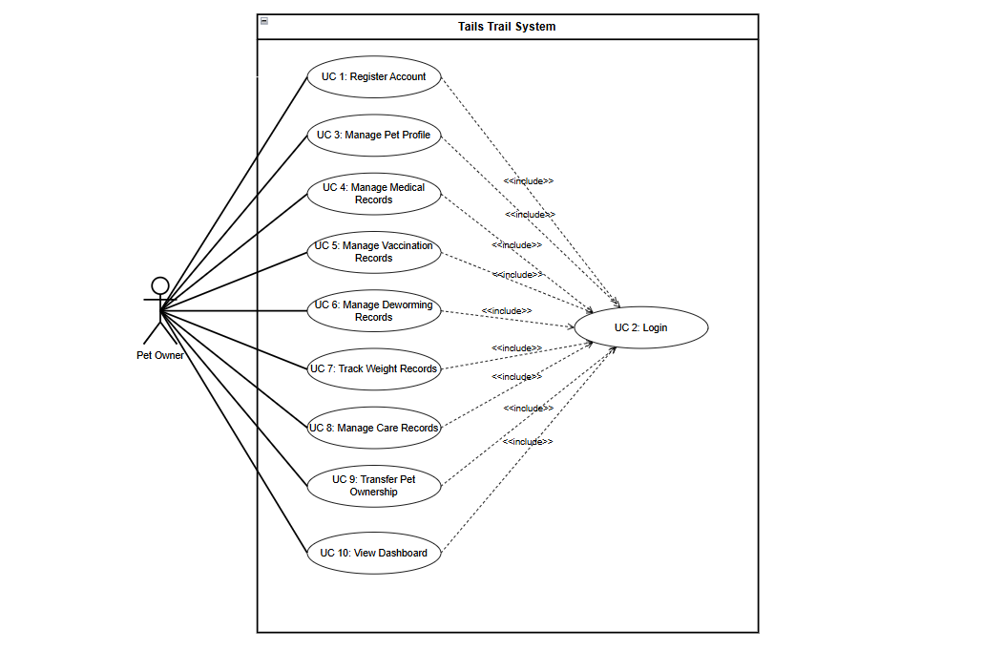

Figure 3.1: Use Case Diagram of Tails Trail
Primary Actor: Pet Owner
The primary actor in the system is the Pet Owner. The Pet Owner is a registered user who accesses the application through a web browser and interacts with different modules to manage pet-related information.
The Pet Owner is responsible for:
- Registering and maintaining a user account.
- Logging into the system securely.
- Managing multiple pet profiles.
- Recording and maintaining healthcare information.
- Tracking vaccination and deworming schedules.
- Monitoring pet growth through weight records.
- Recording daily care activities.
- Managing pet ownership transfers.
- Viewing pet information through the dashboard.
Since all system functionalities are accessed through the Pet Owner, this actor serves as the central user of the application.
Use Case: Register Account
The Register Account use case allows new users to create an account within the system.
Before accessing the application's features, a user must provide personal information such as name, email address, and password. The system validates the information and stores the account details securely in the database. Passwords are encrypted before storage to ensure security.
Successful registration enables the user to access the system using their login credentials.
Use Case: Login
The Login use case enables registered users to authenticate themselves and gain access to system resources.
The user enters a valid email address and password. The system verifies the credentials and grants access to the dashboard if authentication is successful. JWT-based authentication is used to maintain secure user sessions.
This use case acts as a prerequisite for most system functionalities.
Use Case: Manage Pet Profile
The Manage Pet Profile use case allows users to maintain detailed information about their pets.
Through this functionality, users can:
- Add new pets.
- View pet information.
- Update pet details.
- Delete pet profiles.
Information stored includes pet name, species, breed, gender, date of birth, and profile image.
One of the primary goals of the system is to support multiple pets under a single owner account. Therefore, this use case plays a central role in the application.
Use Case: Manage Medical Records
This use case allows users to store and manage pet healthcare information.
Medical records may include:
- Diagnoses
- Treatments
- Medications
- Surgeries
- Veterinary visits
The system provides facilities for adding, updating, viewing, and deleting medical records. Maintaining a digital healthcare history helps owners monitor their pets' medical conditions over time.
Use Case: Manage Vaccination Records
Vaccination management is essential for maintaining pet health and preventing diseases.
This use case allows users to:
- Record vaccinations.
- Update vaccination details.
- View vaccination history.
- Track upcoming vaccination schedules.
Each vaccination record contains information such as vaccine name, administration date, and next due date.
The system helps users ensure that vaccinations are administered on time.
Use Case: Manage Deworming Records
Regular deworming is important for protecting pets from internal parasites.
The Manage Deworming Records use case enables users to:
- Record deworming treatments.
- View previous deworming history.
- Update treatment information.
- Monitor future deworming schedules.
By maintaining a complete history of deworming activities, the system assists owners in ensuring proper preventive healthcare.
Use Case: Track Weight Records
The Track Weight Records use case helps users monitor the growth and overall health of their pets.
Users can periodically enter weight measurements and review historical records. These records can be used to identify unusual weight gain or loss, which may indicate potential health issues.
The system maintains chronological weight records for each pet, allowing long-term growth tracking.
Use Case: Manage Care Records
The Manage Care Records use case allows users to document daily pet care activities.
Examples include:
- Feeding schedules
- Grooming activities
- Exercise routines
- General care notes
Maintaining care records enables owners to keep track of routine activities and ensure consistent pet care.
Use Case: Transfer Pet Ownership
The Transfer Pet Ownership use case represents one of the most significant and unique features of the Tails Trail system.
In many traditional pet management systems, ownership changes often result in incomplete record transfers or loss of healthcare history. Tails Trail addresses this problem by allowing ownership information to be updated while preserving all existing records associated with the pet.
Through this functionality, users can:
- Transfer a pet to a new owner.
- Record transfer details.
- Preserve medical history.
- Preserve vaccination records.
- Preserve deworming records.
- Preserve weight history.
- Preserve care records.
- Maintain transfer history.
This feature ensures that a pet retains a complete digital identity throughout its lifetime regardless of ownership changes.
Use Case: View Dashboard
The View Dashboard use case provides users with a centralized overview of system information.
The dashboard displays:
- Registered pet profiles.
- Recent healthcare activities.
- Vaccination information.
- Deworming schedules.
- Weight records.
- Care records.
The dashboard serves as the main navigation point and provides quick access to all system functionalities.
Relationship Among Use Cases
Several use cases require successful authentication before they can be accessed. Therefore, Login acts as a prerequisite for:
- Manage Pet Profile
- Manage Medical Records
- Manage Vaccination Records
- Manage Deworming Records
- Track Weight Records
- Manage Care Records
- Transfer Pet Ownership
- View Dashboard
This relationship ensures that only authorized users can access and modify pet-related information.

Summary
The Use Case Diagram provides a comprehensive overview of how the Pet Owner interacts with the Tails Trail system. It highlights the major functionalities including user authentication, pet profile management, healthcare record maintenance, vaccination and deworming tracking, weight monitoring, care activity management, and ownership transfer. Among these functionalities, the Ownership Transfer feature serves as a distinguishing characteristic of the system by preserving a pet's complete history during adoption or ownership changes. The diagram demonstrates how the various modules work together to provide an efficient and centralized solution for pet care and health record management.

3.4.2 Activity Diagram
Overview
The Activity Diagram illustrates the workflow of the Tails Trail Pet Care and Health Record Management System. It represents the sequence of activities performed by a pet owner while interacting with the system, from user authentication to pet healthcare management and ownership transfer. The diagram shows how information flows through different modules and how the system responds to user actions at various decision points.
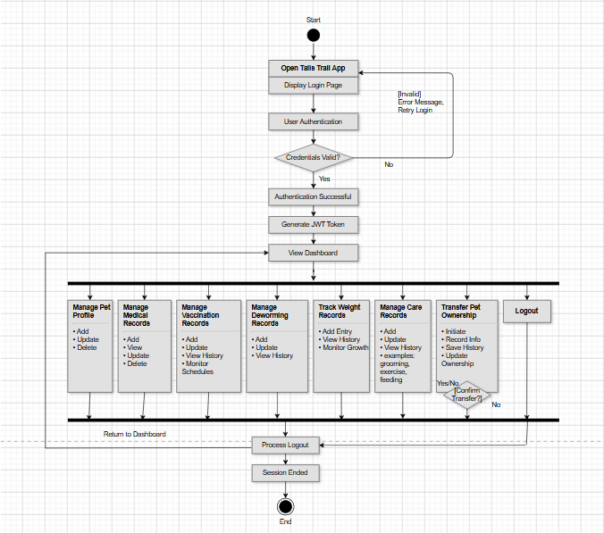

Figure 3.2: Activity Diagram of Tails Trail

Activity Flow Description
The activity begins when the user accesses the Tails Trail web application. The system initially displays the login page and waits for the user to enter valid authentication credentials. The user provides an email address and password, which are verified against the information stored in the database.
A decision point is used to determine whether the provided credentials are valid. If the credentials are incorrect, the system displays an error message and redirects the user back to the login page for another attempt. If the credentials are valid, the system successfully authenticates the user, generates a secure session token, and grants access to the main dashboard.
The dashboard acts as the central control panel of the system. From this interface, users can access various modules including pet profile management, medical records, vaccination records, deworming schedules, weight tracking, care records, and ownership transfer management. The dashboard provides an organized overview of pet-related information and serves as the primary navigation point within the application.
One of the main activities available to users is Pet Profile Management. Through this module, users can add new pets, update existing pet information, view pet details, or remove pet profiles when necessary. Information such as pet name, species, breed, gender, date of birth, and profile image can be maintained within the system. All submitted information is validated before being stored in the database.
The Medical Records Management activity enables users to maintain healthcare information for each pet. Users can add diagnoses, treatment details, medication information, and veterinary visit records. Existing records can also be updated or removed when necessary. This functionality ensures that complete medical histories are maintained for future reference.
The Vaccination Management activity allows users to record and monitor vaccination information. Users can add vaccination details, update existing records, and view vaccination histories. Information such as vaccine name, administration date, and next vaccination due date is stored and managed within the system. This feature helps pet owners ensure timely vaccination schedules.
The Deworming Management activity supports the maintenance of parasite prevention records. Users can enter deworming information, update treatment schedules, and review previous deworming activities. The system stores these records and allows users to monitor future treatment requirements.
The Weight Tracking activity enables users to monitor pet growth and overall health through periodic weight measurements. Users can add new weight entries, review historical records, and observe changes over time. Weight data is validated before being stored in the database, ensuring accurate health monitoring.
The Care Records Management activity allows users to document daily pet care routines such as feeding, grooming, exercise, and other important activities. These records help owners maintain consistent care schedules and create a comprehensive history of pet-related activities.
A unique component of the workflow is the Pet Ownership Transfer activity. This feature allows users to transfer ownership of a pet while preserving all associated records. When a transfer is initiated, the system retrieves the selected pet profile and requests new owner information along with transfer details. A decision point is used to confirm the transfer process. If the transfer is cancelled, the system returns to the dashboard without making any changes. If the transfer is confirmed, ownership information is updated while preserving medical records, vaccination history, deworming records, weight history, care records, and previous ownership information. This functionality ensures continuity of information throughout the pet's lifetime and represents one of the key innovations of the Tails Trail system.
After completing the required operations, the user may choose to log out of the system. During logout, the system invalidates the active session token, clears authentication information, and redirects the user back to the login page. The activity flow then reaches its termination point.
Summary
The Activity Diagram provides a comprehensive representation of the operational workflow of the Tails Trail system. It begins with user authentication and continues through various healthcare management activities including pet profile management, medical record maintenance, vaccination tracking, deworming management, weight monitoring, care record management, and ownership transfer. Decision nodes ensure proper validation and secure processing of information throughout the workflow. The activity concludes when the user logs out, completing the interaction cycle.
The major activities represented in the diagram include:
- User Authentication
- Dashboard Access
- Pet Profile Management
- Medical Records Management
- Vaccination Management
- Deworming Management
- Weight Tracking
- Care Records Management
- Pet Ownership Transfer
- User Logout
The workflow demonstrates how the system supports efficient, secure, and organized management of pet healthcare information while maintaining data integrity and preserving historical records during ownership transitions.

3.4.3 Class Diagram
Overview
The Class Diagram of the Tails Trail Pet Care and Health Record Management System represents the static structure of the application. It illustrates the major classes, their attributes, methods, and the relationships among them. The diagram serves as a blueprint of the system by showing how data is organized and how different components interact to support pet healthcare and ownership management.
The design of the class diagram was developed based on the system requirements and database structure. The primary classes identified in the system are Owner, Pet, MedicalRecord, VaccinationRecord, DewormingRecord, WeightRecord, CareRecord, and TransferRecord. These classes collectively support the core functionalities of the application and ensure efficient management of pet-related information.
Figure 3.3: Class Diagram of Tails Trail
Owner Class
The Owner class represents registered users of the system. Every user must create an account before accessing the application's functionalities. This class is responsible for handling user authentication and account management operations. It stores essential owner information such as name, email address, password, phone number, and address.
The Owner class provides functionalities for account registration, login, profile management, and logout operations. It serves as the parent entity responsible for maintaining ownership information of pets within the system.
Pet Class
The Pet class is the central component of the system and stores all information related to individual pets. Each pet is associated with a specific owner through a unique owner identifier. Information such as pet name, species, breed, gender, date of birth, and profile image is maintained within this class.
The Pet class supports operations such as adding, viewing, updating, and deleting pet information. Since all healthcare-related records are linked to pets, this class acts as the primary entity around which the entire system is organized.
MedicalRecord Class
The MedicalRecord class stores healthcare information related to pets. It maintains details such as diagnoses, treatments, medications, and veterinary visits. Through this class, users can create, update, view, and remove medical records when necessary.
The purpose of this class is to preserve a complete medical history for each pet, allowing owners to track health conditions and treatments over time.
VaccinationRecord Class
The VaccinationRecord class manages vaccination-related information. It stores details regarding vaccine names, administration dates, and upcoming vaccination schedules. The class enables users to maintain vaccination histories and monitor future immunization requirements.
This functionality helps pet owners ensure that pets receive vaccinations on time and maintain proper healthcare standards.
DewormingRecord Class
The DewormingRecord class is responsible for maintaining records related to parasite prevention treatments. It stores information regarding deworming medications, treatment dates, and future schedules.
The class allows users to track previous deworming activities and monitor upcoming treatments, contributing to preventive healthcare management.
WeightRecord Class
The WeightRecord class stores weight measurements recorded for individual pets. Since weight changes often indicate health conditions, maintaining historical weight data is important for monitoring growth and overall well-being.
This class allows users to add, update, and review weight measurements recorded at different points in time.
CareRecord Class
The CareRecord class maintains records of daily pet care activities. Information such as feeding schedules, grooming activities, exercise routines, and general care notes can be stored and managed through this class.
By maintaining detailed care records, the system helps owners ensure consistent and organized pet care management.
TransferRecord Class
The TransferRecord class manages pet ownership transfer information. This class represents one of the most important features of the Tails Trail system. It stores information regarding ownership changes, including previous owner details, new owner information, and transfer dates.
The class ensures that ownership changes are properly documented while preserving all healthcare and historical records associated with the pet. This functionality supports pet adoption and rehoming without losing valuable information.
Relationships Among Classes
The relationships between classes are primarily based on one-to-many associations. The Owner class maintains a one-to-many relationship with the Pet class, meaning that a single owner can manage multiple pets, while each pet belongs to only one owner at a given time.
Similarly, the Pet class maintains one-to-many relationships with the MedicalRecord, VaccinationRecord, DewormingRecord, WeightRecord, CareRecord, and TransferRecord classes. This design allows a single pet to possess multiple healthcare records, vaccination histories, weight measurements, care activities, and ownership transfer records throughout its lifetime.
The Pet class therefore acts as the central entity of the system, linking all healthcare and ownership-related information through well-defined associations.
Class Structure Summary
The overall class hierarchy places the Owner class at the top level, followed by the Pet class as the primary entity. All healthcare and management-related classes are associated with the Pet class through one-to-many relationships. This structure ensures efficient organization of data while supporting scalability and maintainability of the system.
The design also aligns with the relational database structure used in the project, ensuring consistency between the object-oriented model and the database implementation.
Summary
The Class Diagram provides a detailed representation of the structural design of the Tails Trail system. By defining the major classes, their responsibilities, and their relationships, the diagram demonstrates how different components collaborate to support pet profile management, healthcare record maintenance, care activity tracking, and ownership transfer. The modular design improves maintainability, promotes data integrity, and supports future system enhancements while ensuring efficient management of pet healthcare information.

Figure 3.3: Class Diagram of Tails Trail

3.4.4 System Architecture Diagram
Overview
The Architecture Diagram of the Tails Trail Pet Care and Health Record Management System illustrates the overall structure of the application and the interactions between its major components. The system follows a Three-Tier Architecture, consisting of the Presentation Layer, Application Layer, and Database Layer. This architectural approach separates the user interface, business logic, and data storage components into independent layers, improving maintainability, scalability, security, and overall system performance.
The architecture enables pet owners to access the system through a web browser, manage pet-related information, and securely store or retrieve healthcare records from the database. Each layer performs specific responsibilities while communicating with the adjacent layers to ensure efficient operation of the system.
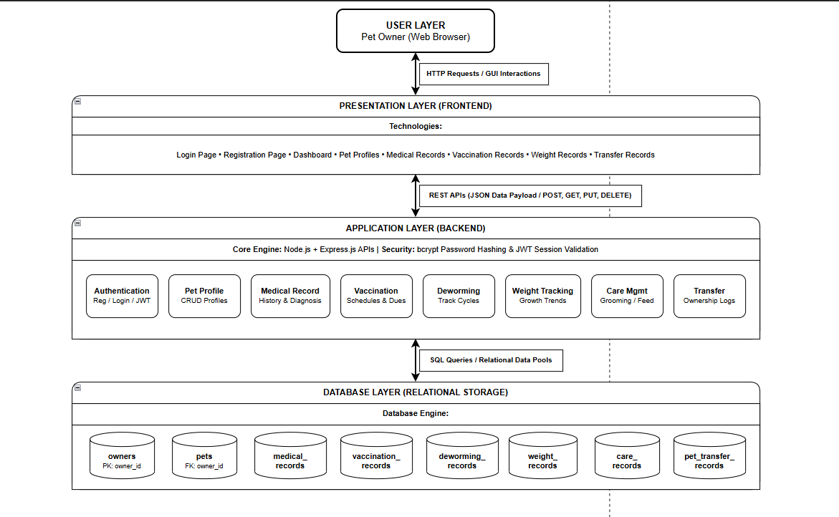

Figure 3.4: System Architecture Diagram of Tails Trail
User Layer
The User Layer represents the pet owner who interacts with the system. The user accesses the application through a web browser and performs various activities such as account registration, login, pet profile management, medical record maintenance, vaccination tracking, deworming management, weight monitoring, care activity recording, and pet ownership transfer.
As the primary actor of the system, the pet owner initiates all requests and receives responses through the user interface. Every interaction with the application begins at this layer and is processed through the underlying system components.
Presentation Layer
The Presentation Layer serves as the frontend of the application and is responsible for displaying information and collecting user input. This layer was developed using HTML, CSS, and JavaScript to provide a responsive and user-friendly interface.
The Presentation Layer includes interfaces for user registration, login, dashboard access, pet profile management, healthcare record management, vaccination tracking, weight monitoring, care activity recording, and ownership transfer. It allows users to interact with the system in an intuitive manner without requiring knowledge of the underlying technical implementation.
Whenever a user performs an action, such as adding a new pet or updating a medical record, the frontend collects the required information and sends an HTTP request to the backend server for processing. The results returned by the server are then displayed to the user in the form of updated information, notifications, or confirmation messages.
Application Layer
The Application Layer acts as the core processing component of the system. It contains the business logic, API endpoints, authentication services, validation mechanisms, and data processing functions required to support system operations. This layer was developed using Node.js and Express.js.
The Application Layer functions as an intermediary between the frontend and the database. It receives requests from the user interface, validates incoming data, applies business rules, communicates with the database, and generates appropriate responses.
Several functional modules operate within this layer. The Authentication Module handles user registration, login verification, password encryption, JWT token generation, and access control. The Pet Management Module is responsible for creating, updating, retrieving, and deleting pet information. Additional modules manage medical records, vaccination schedules, deworming records, weight tracking information, and daily care activities.
A particularly important component is the Ownership Transfer Module. This module manages the transfer of pets between owners while preserving complete healthcare histories and ownership records. Unlike many conventional pet management systems, Tails Trail maintains all associated records during ownership transitions, ensuring continuity of information throughout the pet's lifetime.
The Application Layer also performs extensive data validation before information is stored in the database. Validation checks include required field verification, email format validation, password security requirements, and prevention of invalid or duplicate records. These mechanisms help maintain data accuracy and reliability.
Database Layer
The Database Layer is responsible for the permanent storage and retrieval of application data. The system utilizes MySQL as its relational database management system due to its reliability, scalability, and support for structured data relationships.
The database stores all information required by the application, including user accounts, pet profiles, medical histories, vaccination records, deworming schedules, weight measurements, care activities, and ownership transfer records. Data is organized into multiple related tables to ensure efficient storage and retrieval.
Primary keys are used to uniquely identify individual records, while foreign keys establish relationships among entities. For example, each pet is linked to its owner through an owner identifier, and healthcare records are linked to specific pets through pet identifiers. These relationships maintain referential integrity throughout the system.
To improve consistency and reduce redundancy, the database design follows Third Normal Form (3NF) principles. Data is separated into logical entities, ensuring that information is stored only once and minimizing update anomalies.
System Workflow
The system workflow begins when a pet owner performs an action through the user interface. The frontend collects the required input and sends a request to the backend server. The backend then validates the information, applies the necessary business logic, and communicates with the database to retrieve or modify data.
After the requested operation is completed, the database returns the results to the backend. The backend processes the information and sends an appropriate response to the frontend. Finally, the frontend displays updated information, confirmation messages, or error notifications to the user. This workflow ensures smooth communication between all architectural layers and enables efficient management of pet-related information.
Security Architecture
Security is an important aspect of the Tails Trail system. Passwords are protected using bcrypt hashing, preventing the storage of plain-text passwords within the database. User authentication and session management are implemented using JSON Web Tokens (JWT), ensuring that only authenticated users can access protected resources.
In addition, all incoming data undergoes validation before processing. These validation mechanisms help prevent invalid data entry, unauthorized access attempts, and potential data inconsistencies, thereby enhancing the overall reliability and security of the system.
Advantages of the Architecture
The three-tier architecture adopted for Tails Trail provides several advantages. The separation of responsibilities improves modularity, allowing each layer to function independently. The system can be maintained and updated more easily because modifications in one layer have minimal impact on others. The architecture also supports future scalability, enabling additional modules and functionalities to be integrated without major redesign.
Furthermore, the use of authentication, validation, and structured database relationships enhances security and data integrity. Efficient communication between layers contributes to reliable system performance and a positive user experience.
Summary
The Architecture Diagram provides a comprehensive view of the structural design and communication flow of the Tails Trail system. The Presentation Layer handles user interaction, the Application Layer processes requests and implements business logic, and the Database Layer manages persistent data storage. Together, these layers create a secure, scalable, and maintainable platform for managing pet profiles, healthcare records, care activities, and ownership transfer information. The architecture ensures efficient operation while supporting the long-term goal of comprehensive pet healthcare management.

3.5 Database Design
A relational database was designed using MySQL. The database stores information related to:
- Owners
- Pets
- Medical Records
- Vaccination Records
- Deworming Records
- Weight Records
- Care Records
- Transfer Records

3.5.1 Entity Relationship Diagram (ERD)
Overview
The Entity Relationship (ER) Diagram of the Tails Trail Pet Care and Health Record Management System illustrates the logical structure of the database and the relationships among the entities used within the system. It provides a visual representation of how data is organized, stored, and connected to support the various functionalities of the application.
The ER Diagram was developed based on the system requirements and database design principles. It ensures efficient data storage, minimizes redundancy, maintains data integrity, and supports effective retrieval of pet-related information. The database follows normalization principles and utilizes primary and foreign key constraints to establish relationships between entities.
The major entities identified in the system are Owners, Pets, Medical Records, Vaccination Records, Deworming Records, Weight Records, Care Records, and Pet Transfer Records. Among these entities, the Pets table serves as the central entity because all healthcare and ownership-related information is associated with individual pets.
Figure 3.5: Entity Relationship Diagram (ERD) of Tails Trail
Owners Entity
The Owners entity stores information about registered users of the system. Every user must create an account before accessing the application's functionalities. This entity contains owner-specific information such as name, email address, password, phone number, and address.
The primary key of this entity is owner_id, which uniquely identifies each owner within the system. The Owners entity serves as the parent entity for pet ownership and establishes relationships with the Pets entity.
Pets Entity
The Pets entity stores detailed information about individual pets. Information maintained includes pet name, species, breed, gender, date of birth, and profile image details. Each pet is associated with a specific owner through the owner_id foreign key.
The primary key of this entity is pet_id, while owner_id acts as a foreign key referencing the Owners table. The Pets entity serves as the central component of the database because all healthcare records, care activities, and ownership transfer information are linked to a specific pet.
Medical Records Entity
The Medical Records entity maintains healthcare information related to pets. It stores diagnoses, treatments, medications, and veterinary visit details. Each medical record is associated with a specific pet through the pet_id foreign key.
The primary key of this entity is medical_id. This entity enables the system to preserve a complete medical history for every pet and supports long-term healthcare monitoring.
Vaccination Records Entity
The Vaccination Records entity stores immunization information for pets. Data maintained includes vaccine names, vaccination dates, and future due dates. Each vaccination record is linked to a pet through the pet_id foreign key.
The primary key is vaccination_id. This entity supports vaccination tracking and helps pet owners maintain timely immunization schedules.
Deworming Records Entity
The Deworming Records entity stores information related to parasite prevention treatments. Details such as medicine name, administration date, and next treatment schedule are maintained within this entity.
The primary key is deworming_id, while pet_id acts as the foreign key. This entity enables the monitoring of deworming schedules and historical treatment records.
Weight Records Entity
The Weight Records entity stores pet growth information through periodic weight measurements. Weight history plays an important role in monitoring pet health and identifying potential medical concerns.
Each record is uniquely identified by weight_id and is associated with a pet through the pet_id foreign key. The entity allows users to maintain chronological weight records throughout a pet's lifetime.
Care Records Entity
The Care Records entity stores information regarding daily pet care activities. These activities may include feeding schedules, grooming sessions, exercise routines, and other important care-related information.
The primary key for this entity is care_id, while pet_id establishes the relationship with the Pets entity. This structure enables owners to maintain organized records of routine pet care activities.
Pet Transfer Records Entity
The Pet Transfer Records entity is one of the most significant components of the database design. It stores ownership transfer information whenever a pet changes ownership.
The entity contains details such as transfer date, previous owner information, and new owner information. The primary key is transfer_id, while pet_id, previous_owner_id, and new_owner_id serve as foreign keys referencing the appropriate entities.
This entity supports the unique ownership transfer feature of Tails Trail by preserving complete ownership history while maintaining all healthcare records associated with the pet.
Relationship Analysis
The relationships between entities are primarily based on one-to-many associations. The Owners entity maintains a one-to-many relationship with the Pets entity, indicating that a single owner can manage multiple pets while each pet belongs to one owner at a given time.
Similarly, the Pets entity maintains one-to-many relationships with the Medical Records, Vaccination Records, Deworming Records, Weight Records, Care Records, and Pet Transfer Records entities. This design allows a single pet to accumulate multiple healthcare records, vaccination histories, weight measurements, care activities, and ownership transfer records throughout its lifetime.
The Pet Transfer Records entity maintains additional relationships with the Owners entity by storing references to both previous and new owners. This design ensures accurate documentation of ownership transitions and supports the preservation of pet history during adoption or transfer.
Database Normalization
The database design follows Third Normal Form (3NF) to improve data integrity and reduce redundancy.
In the First Normal Form (1NF), all attributes contain atomic values and repeating groups are eliminated. In the Second Normal Form (2NF), all non-key attributes are fully dependent on their respective primary keys. Finally, in the Third Normal Form (3NF), transitive dependencies are removed by ensuring that each table stores only information directly related to its primary key.
For example, owner information is stored separately in the Owners table rather than being repeatedly stored within the Pets table. Similarly, medical records, vaccinations, deworming schedules, care activities, and ownership transfers are maintained in dedicated tables connected through foreign key relationships.
This normalization approach reduces duplicate data, improves consistency, and simplifies database maintenance.
Summary
The Entity Relationship Diagram provides a structured representation of the Tails Trail database system. The Owners entity manages user information, while the Pets entity serves as the central component connecting all healthcare and ownership-related records. Through properly defined primary keys, foreign keys, and one-to-many relationships, the database efficiently stores medical histories, vaccination schedules, deworming records, weight tracking information, care activities, and ownership transfer data.
The design ensures data integrity, minimizes redundancy, and supports the overall objective of providing a comprehensive pet healthcare and ownership management platform. Furthermore, the inclusion of the Pet Transfer Records entity enables the system to preserve complete pet histories during ownership changes, making it one of the distinguishing features of the Tails Trail system.

3.6 GUI / UI Design
Overview
The Graphical User Interface (GUI) of the Tails Trail Pet Care and Health Record Management System was designed with a focus on simplicity, usability, and efficient navigation. The interface enables pet owners to easily manage multiple pets and maintain healthcare records through a clean and organized web-based environment.
The design emphasizes user-friendly interaction by providing clear navigation menus, structured forms, and intuitive dashboards. The interface was developed using HTML, CSS, and JavaScript to ensure responsiveness and accessibility across different devices and screen sizes.
The system follows a consistent design approach throughout all modules, allowing users to access pet-related information efficiently while minimizing complexity.
Login Interface
The Login Interface serves as the entry point to the system. Registered users can securely access their accounts by providing their email address and password. The interface validates user credentials and redirects authenticated users to the main dashboard.
This page was designed to provide a simple and secure authentication process while ensuring ease of use for all users.

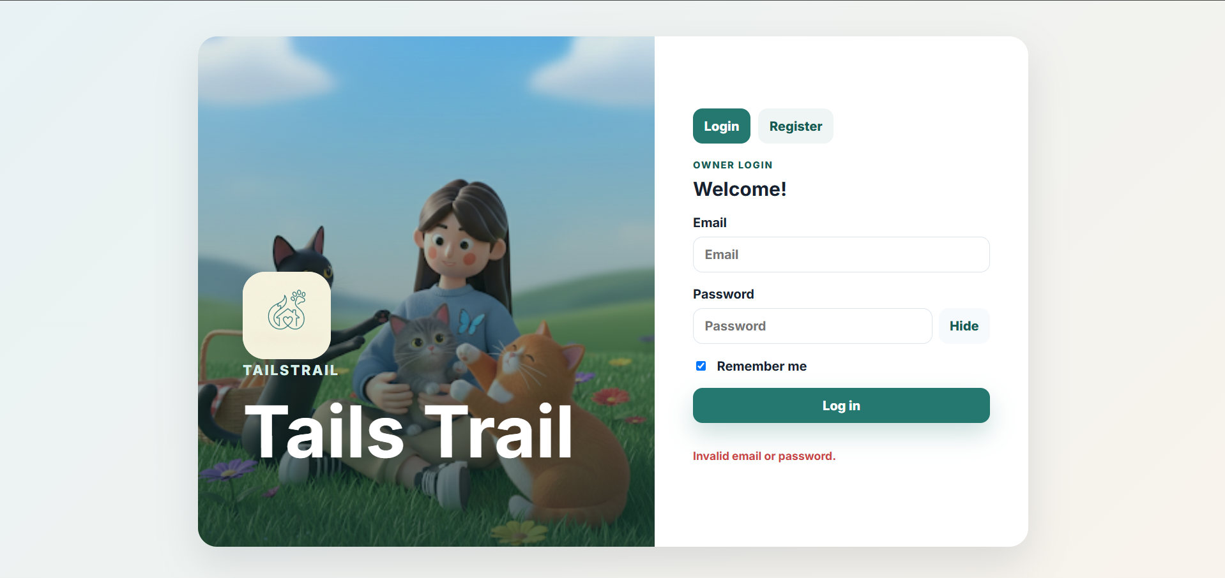Figure 3.6: Login Interface

Dashboard Interface
The Dashboard serves as the central control panel of the application. After successful login, users are redirected to this page where they can view and access all major system modules.
The dashboard provides quick access to:
- Pet Profiles
- Medical Records
- Vaccination Records
- Deworming Records
- Weight Tracking
- Care Records
- Ownership Transfer Features
The dashboard design allows users to efficiently navigate through the application and monitor pet-related information from a single location.

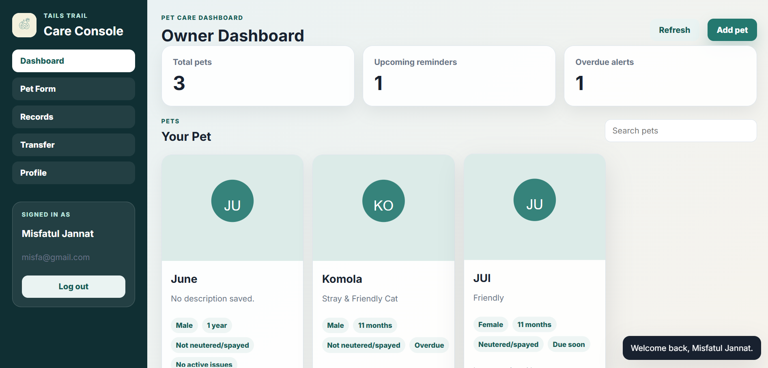

Figure 3.7: Dashboard Interface
Pet Management Interface
The Pet Management Interface allows users to add, update, view, and remove pet profiles. The interface contains forms for entering pet information such as name, species, breed, gender, date of birth, and profile image.
Users can manage multiple pets under a single account, making it easier to maintain organized records for all pets.

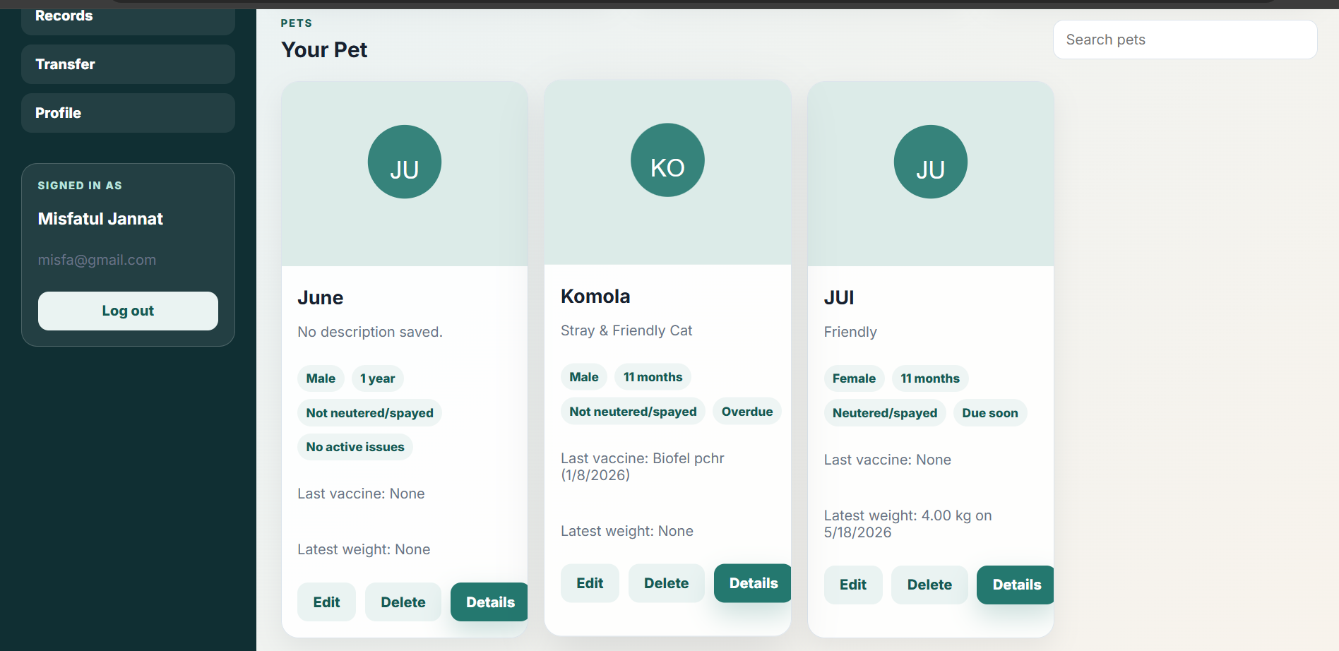

Figure 3.8: Pet Management Interface

Pet Ownership Transfer Interface
The Pet Ownership Transfer Interface is one of the most important features of the Tails Trail system. It allows users to transfer ownership of a pet while preserving all associated healthcare records, vaccination history, care records, weight tracking information, and previous ownership data.
Users can enter transfer details, specify the new owner, and confirm the transfer process. The system updates ownership information while maintaining the complete history of the pet.
This feature distinguishes Tails Trail from many traditional pet management systems and supports efficient pet adoption and ownership transitions.

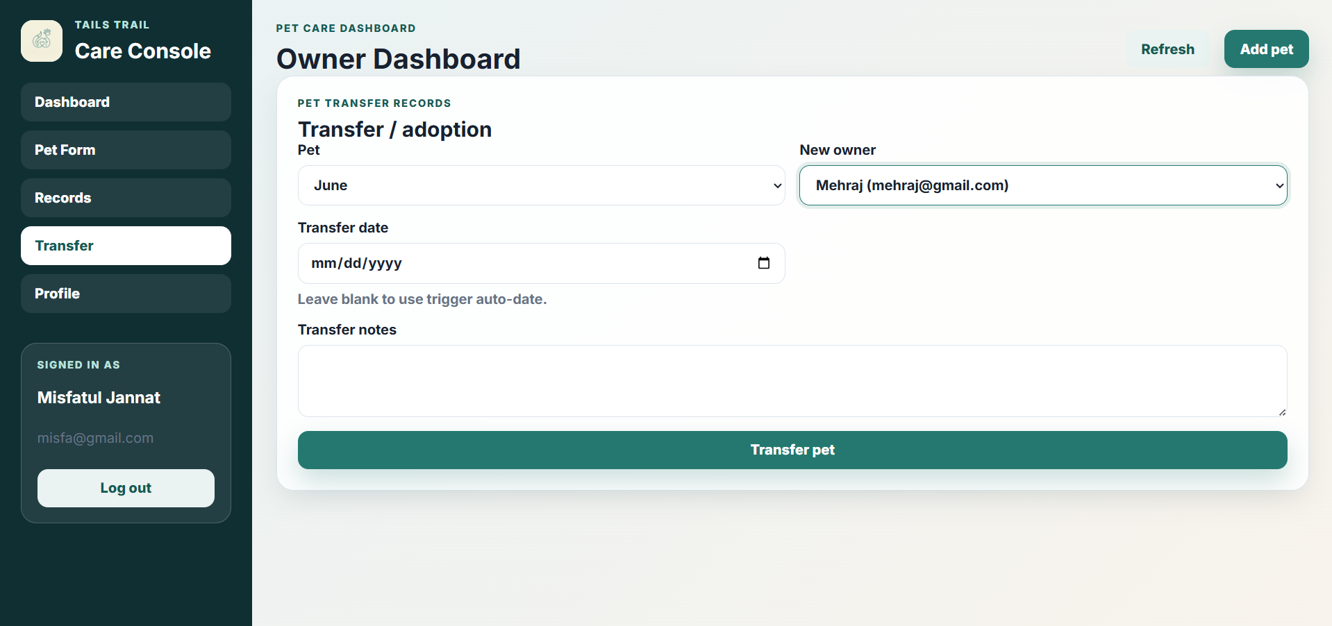

Figure 3.9: Ownership Transfer Interface
User Interface Design Considerations
Several design principles were considered during the development of the user interface:
- Simplicity and ease of use.
- Consistent navigation across all modules.
- Responsive design for different screen sizes.
- Clear form layouts for data entry.
- Organized presentation of healthcare information.
- Efficient access to frequently used features.
- Secure handling of user authentication and sensitive information.
Summary
The GUI of the Tails Trail system was designed to provide an intuitive and user-friendly environment for managing pet healthcare information. Through dedicated interfaces for authentication, pet management, healthcare records, vaccination tracking, care management, and ownership transfer, the system enables users to efficiently organize and maintain complete pet histories. The consistent and responsive design enhances usability while supporting the overall objectives of the project.

3.7 Tools and Technologies Used

Hardware Requirements
Component | Specification
Processor | Intel Core i3 or higher
RAM | 4 GB or higher
Storage | 10 GB available space
Internet | Required

Software Requirements
Technology | Purpose
HTML | Frontend Structure
CSS | Styling
JavaScript | Client-side Logic
Node.js | Backend Runtime
Express.js | Web Framework
MySQL | Database Management System
JWT | Authentication
bcrypt | Password Encryption
VS Code | Development Environment

CHAPTER 4 : IMPLEMENTATION, TESTING AND RESULTS

4.1 Introduction
This chapter describes the implementation process of the Tails Trail system, the testing procedures performed, and the results obtained after development.

4.2 System Implementation
The system was implemented using a three-tier architecture consisting of frontend, backend, and database layers.

4.2.1 Authentication Module
Features implemented:
- User Registration
- User Login
- JWT Authentication
- Password Encryption using bcrypt

4.2.2 Pet Management Module
Features implemented:
- Add Pet
- Update Pet Information
- Delete Pet
- View Pet Profiles

4.2.3 Healthcare Management Module
This module includes:
- Medical Records Management
- Vaccination Tracking
- Deworming Tracking
- Weight Tracking
- Care Activity Management

4.2.4 Ownership Transfer Module
This is the unique feature of the system. The module allows a pet to be transferred to a new owner while preserving:
- Medical History
- Vaccination Records
- Deworming Records
- Weight History
- Care Records
- Ownership History
The complete history remains attached to the pet, ensuring continuity of information after adoption or transfer.

4.3 Testing Procedures

4.3.1 Unit Testing
Each module was tested independently to ensure correct functionality.
Modules tested:
- Authentication Module
- Pet Management Module
- Medical Records Module
- Vaccination Module
- Transfer Module

4.3.2 Integration Testing
Integration testing verified communication between:
- Frontend and Backend
- Backend and Database
- Frontend and Database through APIs

4.3.3 System Testing
Complete workflows were tested from user registration to pet ownership transfer.

4.4 Test Results
Test Case | Expected Result | Actual Result | Status
User Registration | Account Created | Successful | Pass
User Login | Login Successful | Successful | Pass
Add Pet | Pet Added | Successful | Pass
Add Medical Record | Record Stored | Successful | Pass
Add Vaccination | Vaccination Saved | Successful | Pass
Weight Tracking | Weight Stored | Successful | Pass
Transfer Pet | Ownership Updated | Successful | Pass

4.5 Results Analysis
The developed system successfully achieved all major project objectives. Users were able to manage multiple pets, maintain healthcare records, track vaccinations and deworming schedules, monitor pet growth, and record care activities.
The most significant result was the successful implementation of the Ownership Transfer Module. During testing, all pet-related records remained intact after ownership transfer, demonstrating that the system effectively preserves a pet’s complete history during adoption or transfer.

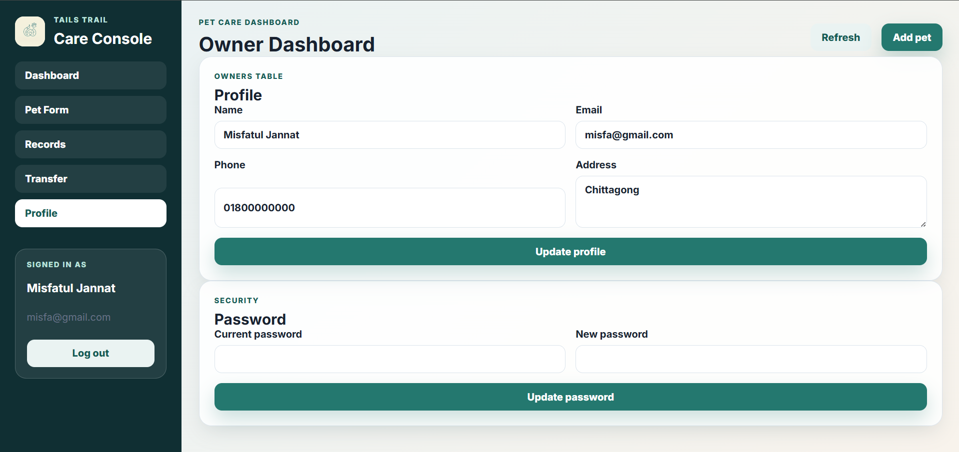Figure 4.1: User Dashboard

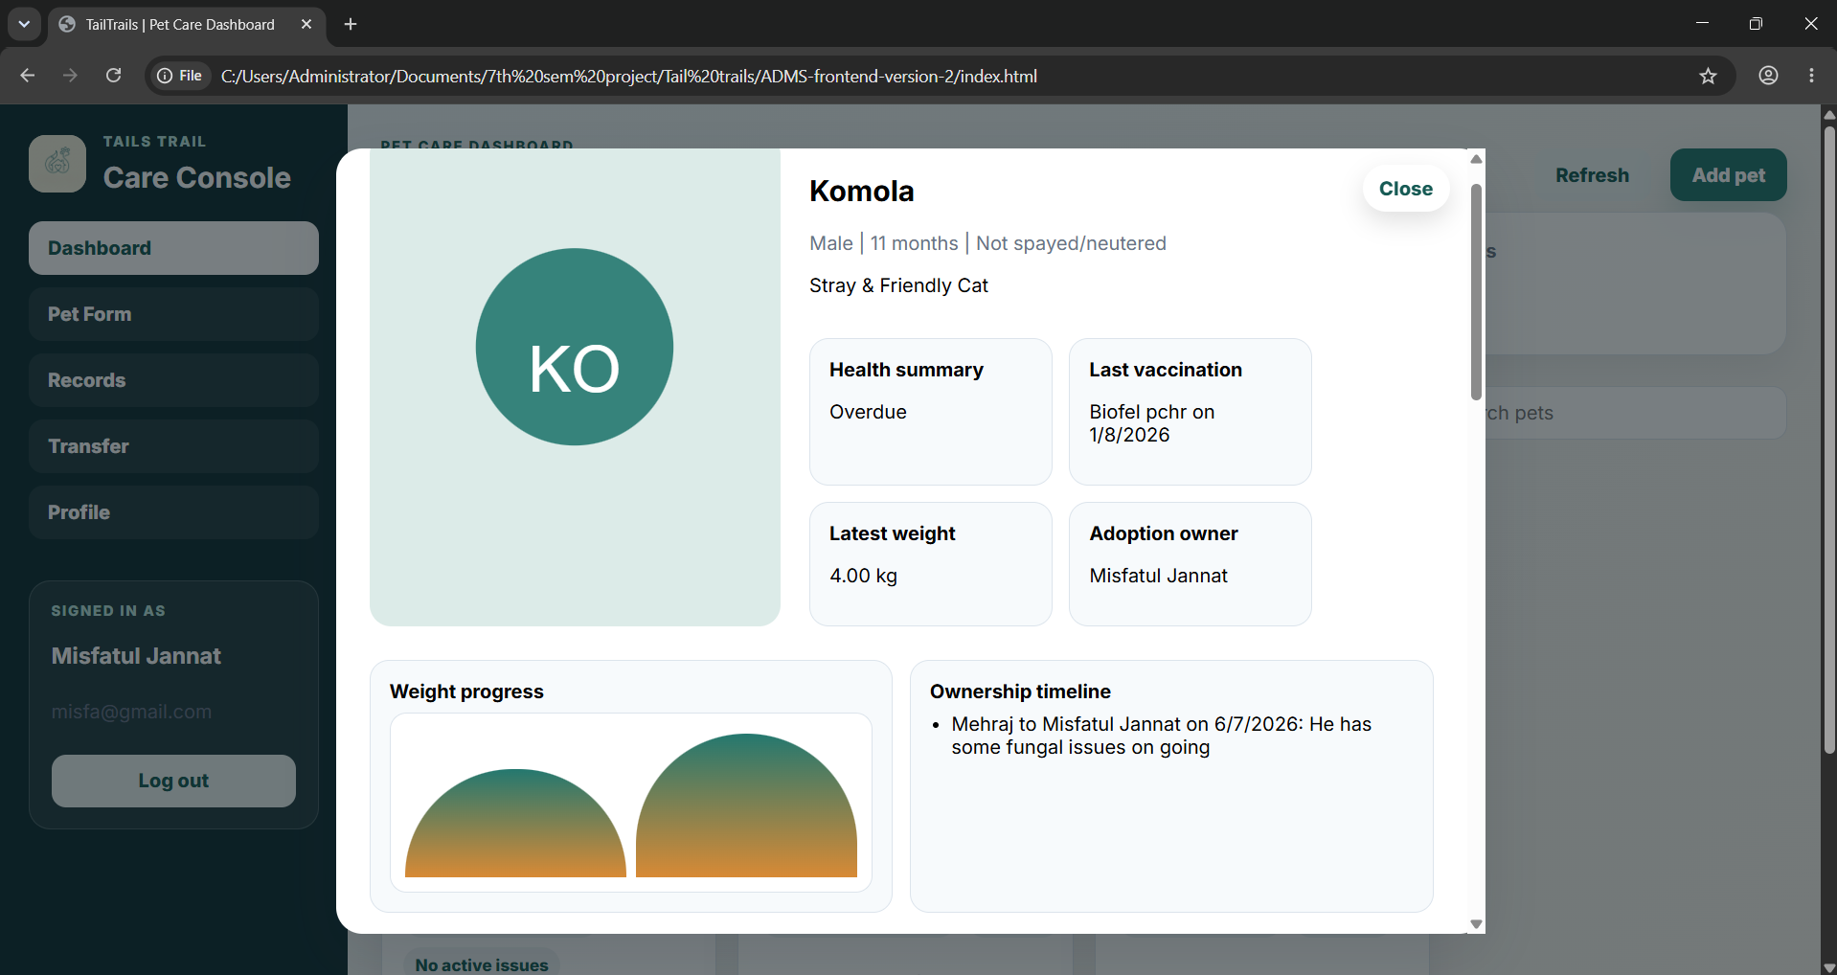

Figure 4.2: Pet Record Management(Detailed)

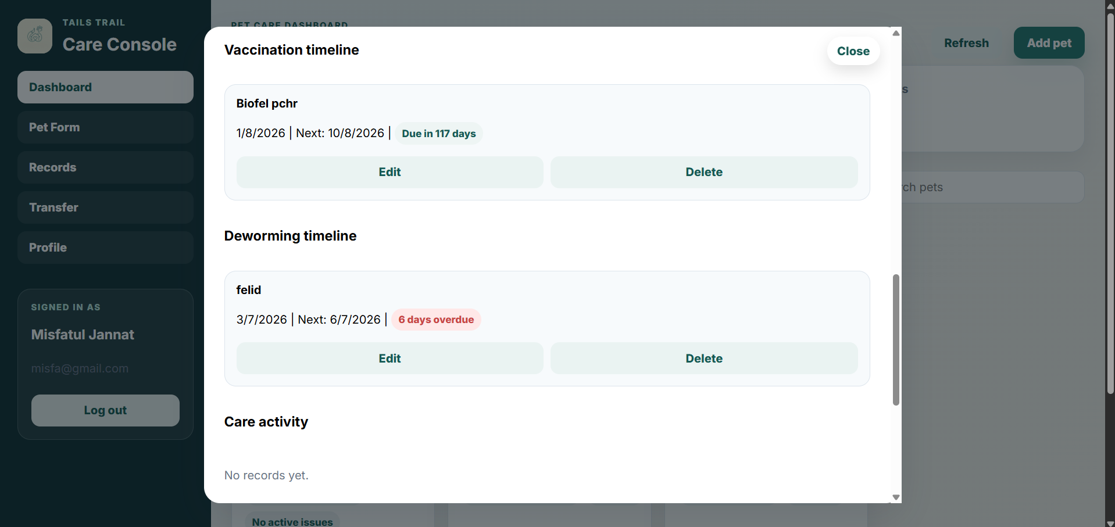Figure 4.3: Vaccination & Deworming Management



Figure 4.4: Ownership Transfer Module

4.6 Evaluation
The system was evaluated against the project objectives.
- Multi-Pet Management: Successfully achieved, allowing users to manage multiple pets under one account.
- Healthcare Record Management: Successfully achieved through efficient storage and retrieval of medical information.
- Ownership Transfer: Successfully achieved with preservation of complete pet history.
- Data Security: Successfully achieved using JWT authentication and password encryption.
- Data Integrity: Successfully achieved through relational database design and normalization.
Overall, the system fulfilled all planned objectives and demonstrated reliable performance during testing.

Chapter 5: Conclusion and Recommendations

5.1 Conclusion
The Tails Trail Pet Care and Health Record Management System was developed to provide pet owners with a centralized platform for managing pet-related information and healthcare records. The system successfully addresses the challenges associated with maintaining pet records manually by providing a secure, organized, and easily accessible digital solution.
The primary objective of the project was to develop a web-based application capable of managing multiple pets, their healthcare information, daily care activities, and ownership history. These objectives were successfully achieved through the implementation of modules for pet profile management, medical record maintenance, vaccination tracking, deworming management, weight monitoring, care activity recording, and ownership transfer management.
One of the most significant achievements of the project is the implementation of the Pet Ownership Transfer feature. This functionality allows ownership information to be transferred while preserving all associated healthcare records and historical data. Unlike traditional record-keeping methods, the system ensures that valuable medical histories and care records remain available even after a pet changes ownership. This feature enhances continuity of care and supports adoption and rehoming processes.
The system was developed using modern web technologies including HTML, CSS, JavaScript, Node.js, Express.js, and MySQL. Authentication and security mechanisms such as JWT authentication and password hashing were implemented to protect user information and maintain data integrity.
Overall, the project successfully met its objectives and demonstrates how technology can be utilized to improve pet healthcare management and ownership record maintenance.

5.2 Summary of Achievements
The major achievements of the project include:
- Development of a complete web-based pet management system.
- Implementation of secure user registration and authentication mechanisms.
- Creation of pet profile management functionalities.
- Development of healthcare record management modules.
- Implementation of vaccination tracking and scheduling features.
- Development of deworming record management functionality.
- Implementation of weight monitoring and growth tracking features.
- Creation of care activity management modules.
- Successful integration of a MySQL relational database following Third Normal Form (3NF).
- Development of a unique pet ownership transfer feature that preserves complete pet history.
- Implementation of a responsive and user-friendly interface.
- Maintenance of data integrity through database relationships and validation mechanisms.

5.3 Challenges Experienced
Several challenges were encountered during the development of the project.
One of the major challenges was designing a database structure capable of managing multiple healthcare-related records while maintaining proper relationships among entities. Careful database normalization and foreign key constraints were required to ensure data consistency.
Another challenge involved implementing secure authentication and authorization mechanisms. User credentials needed to be protected through password hashing and secure token-based authentication.
Managing the relationships between pets, owners, and healthcare records also required careful planning to prevent data redundancy and maintain accurate ownership information.
The implementation of the pet ownership transfer feature presented additional complexity because historical healthcare information needed to remain associated with the pet while ownership information changed. Special consideration was required to preserve data integrity and maintain complete transfer histories.
Testing and debugging various modules, particularly database operations and API communication, also required significant effort to ensure reliable system performance.
Despite these challenges, all identified issues were successfully addressed through systematic development, testing, and validation.

5.4 Recommendations and Future Work
Although the system successfully fulfills its intended objectives, several improvements can be implemented in future versions to enhance functionality and user experience.
Future enhancements may include:
- Development of a mobile application version for Android and iOS platforms.
- Integration of veterinary clinic management features.
- Automated reminders for vaccinations and deworming schedules through email or SMS notifications.
- Integration of pet adoption and rescue organization services.
- Implementation of appointment scheduling with veterinarians.
- Addition of healthcare analytics and reporting features.
- Support for uploading and storing veterinary prescriptions and medical documents.
- Development of emergency healthcare alert systems.
- Integration of cloud storage for improved scalability and data backup.
- Implementation of role-based access control for veterinarians and administrators.
These improvements would further increase the usefulness and scalability of the system while expanding its applicability within the pet healthcare management domain.

References
The following references were consulted during the development of this project:
[1] Oracle Corporation, MySQL Documentation. Available: https://dev.mysql.com/doc/
[2] Node.js Foundation, Node.js Documentation. Available: https://nodejs.org/docs
[3] Express.js, Express Web Framework Documentation. Available: https://expressjs.com/
[4] Mozilla Developer Network (MDN), HTML Documentation. Available: https://developer.mozilla.org/
[5] Mozilla Developer Network (MDN), CSS Documentation. Available: https://developer.mozilla.org/
[6] Mozilla Developer Network (MDN), JavaScript Documentation. Available: https://developer.mozilla.org/
[7] Auth0, JSON Web Token (JWT) Introduction. Available: https://jwt.io/
[8] npm, bcrypt Package Documentation. Available: https://www.npmjs.com/package/bcrypt
[9] GeeksforGeeks, Database Normalization in DBMS. Available: https://www.geeksforgeeks.org/
[10] Silberschatz, A., Korth, H. F., and Sudarshan, S., Database System Concepts, 7th ed., McGraw-Hill Education, 2019.

Appendices
Appendix A: Bill of Materials / Software Requirements
Hardware Requirements
- Processor: Intel Core i3 or higher
- RAM: 4 GB minimum
- Storage: 10 GB available disk space
- Internet Connection
Software Requirements
- Operating System: Windows 10/11
- Visual Studio Code
- Node.js Runtime Environment
- MySQL Database Server
- Web Browser (Google Chrome, Microsoft Edge, Firefox)
- Git (Optional)
Appendix B: Extended Test Results
Authentication Module
Test Case | Expected Result | Status
Valid Login | Access Granted | Pass
Invalid Password | Error Message | Pass
Empty Fields | Validation Error | Pass
Pet Management Module
Test Case | Expected Result | Status
Add Pet | Pet Created Successfully | Pass
Update Pet | Information Updated | Pass
Delete Pet | Pet Removed | Pass
Healthcare Management Module
Test Case | Expected Result | Status
Add Medical Record | Record Saved | Pass
Add Vaccination Record | Record Saved | Pass
Add Deworming Record | Record Saved | Pass
Add Weight Record | Record Saved | Pass
Transfer Module
Test Case | Expected Result | Status
Transfer Pet Ownership | Ownership Updated | Pass
Transfer History Stored | History Preserved | Pass
Appendix C: User Manual
Step 1: Register an Account
- Open the application.
- Navigate to the Registration page.
- Enter personal information.
- Create an account.
Step 2: Login
- Enter email and password.
- Click Login.
- Access the dashboard.
Step 3: Add a Pet
- Open Pet Management.
- Click Add Pet.
- Enter pet information.
- Save the record.
Step 4: Manage Healthcare Records
- Select a pet.
- Open the desired healthcare module.
- Add or update records.
- Save changes.
Step 5: Transfer Ownership
- Select a pet.
- Open Transfer Ownership.
- Enter new owner information.
- Confirm transfer.
Appendix D: Key Source Code Snippets
Database Connection Configuration
const mysql = require("mysql2/promise");
require("dotenv").config();

const pool = mysql.createPool({
host: process.env.DB_HOST || "localhost",
port: Number(process.env.DB_PORT || 3306),
user: process.env.DB_USER || "root",
password: process.env.DB_PASSWORD || "",
database: process.env.DB_NAME || "tailstrail_dbms",
waitForConnections: true,
connectionLimit: 10
});

module.exports = pool;

JWT Authentication Example
const jwt = require("jsonwebtoken");

const token = jwt.sign(
{ userId: user.id },
process.env.JWT_SECRET,
{ expiresIn: "1d" }
);
Password Hashing Example
const bcrypt = require("bcrypt");
const hashedPassword = await bcrypt.hash(password, 10);

